Shifts in Demand

It is possible that demand may change for reasons other than price
DEMAND INCREASES IF (MARS BARS)
1. The good or service becomes more popular
2. Increase in advertising on the good or service
3. Other substitute goods (e.g. twix) increase in price
4. Improvement in quality
5. People have larger incomes
DEMAND FALLS IF
1. The good or service becomes less popular
2. Decrease in advertising on the good or service
3. Other substitute goods fall in price
4. Fall in quality or a health scare
5. People have smaller incomes
DEMAND INCREASE ON A DIAGRAM
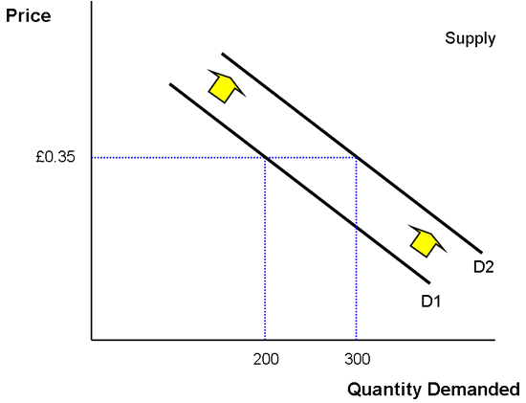
In the example above demand has increased.
At £0.35 previously only 200 mars bars were demanded now 300 mars bars are demanded.
Consequently demand has SHIFTED from D1 to D2

