Unit 11 Personal Economics:   
further guidance using the Jan 2010 past paper

Remember me!? The information below will help you with your exam technique but remember that you have an **exam guide** with more detailed advice!

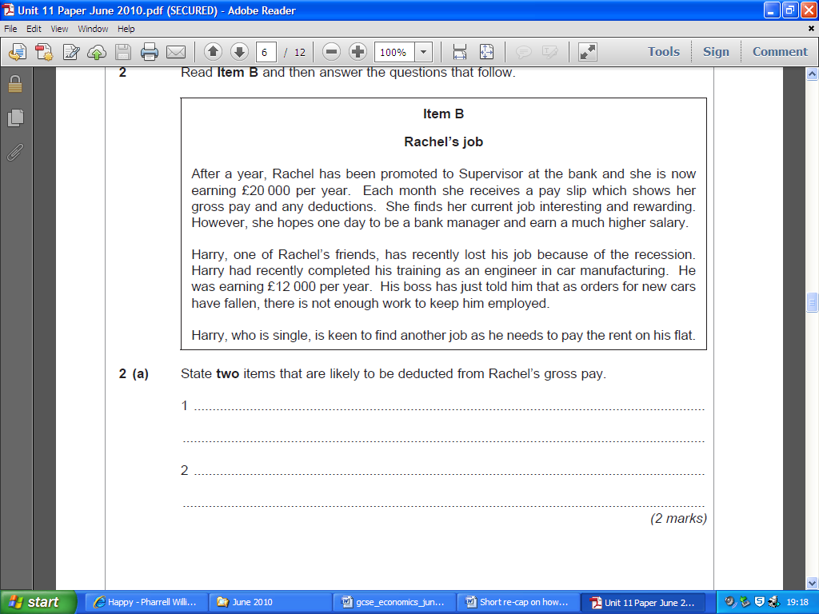



**2 (b) Explain two possible reasons why Harry was paid less than Rachel? (6 marks)**

*Identify where you’d award the marks in the following answer:*

Rachel has been promoted to the role of supervisor. This would suggest that her job involves a greater level of responsibility because she has to ensure workers are completing their job. This means she’ll be paid more as her job is more stressful and challenging.

*Based upon Harry explain a second reason why he may be paid less than Rachel which will obtain 3 marks*

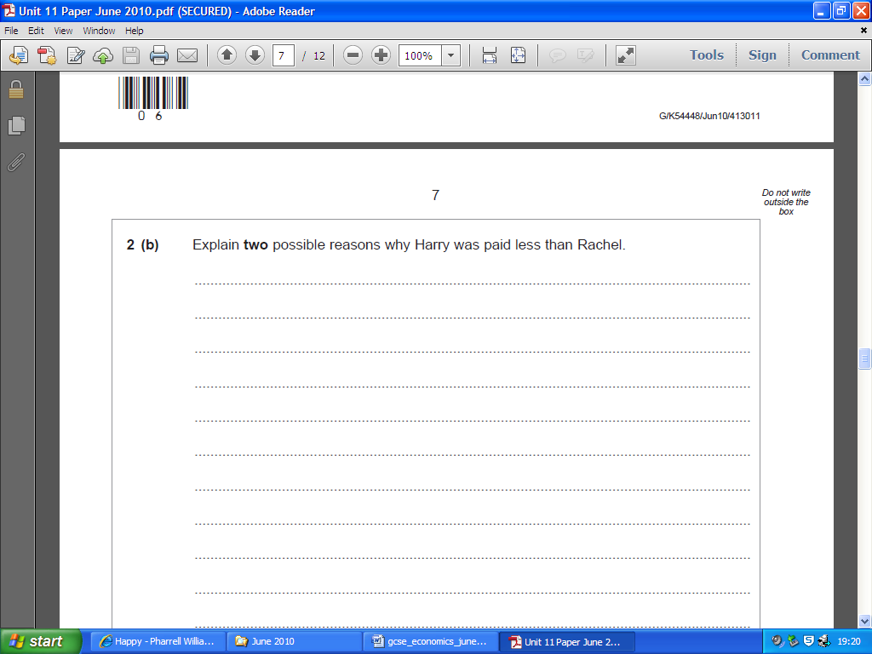

2c.) Recommend to Harry which option he should take?

An advantage of accepting a job for six months is that he’ll still receive close to his £12,000 salary. This is important because he can maintain his current life style. A disadvantage is that it is 200 miles away. This is important as it is unlikely he’ll commute this due to the cost, so he’ll need to relocate.

An advantage of receiving Government benefit is that he can still afford his basic needs while looking for a new job. This is important because needs are required for survival so he’ll hopefully be able to pay the rent on his flat still and not be evicted, by the time he has a new job.

An advantage of retraining is that he’ll have more skills. This is important because he will then be more employable, for example servicing dishwashing machines. This is important as there is less chance of him becoming unemployed in the future. A disadvantage is the £80 a week is unlikely to cover his rent and other basic needs, so he may end up being evicted from his flat.

To evaluate, in my judgement, I believe that Harry should not take option as relocating that far will incur high financial and emotional costs for an opportunity that doesn’t have much reward. For a low paid job assuming it is similar to his current £12,000 and that only lasts for 6 months I don’t believe it is worth it because he could be in the same situation in 6 months without his friends around to help him. As Harry is keen to find another job because he wants to keep his flat I’d advise him to take the benefits and look for a job in any industry as he’ll receive £12,000 on any minimum wage job, which will allow him to keep the flat. Then he can look for a job that he enjoys more, like being an engineer. He should do the college course if he cannot find a job as he needs more skills to become employable, otherwise he might spend the rest of his life at his parents and never have his own property again.

What are two things could you change to improve this extended essay answer

