Group Activity:
The European Union: What do you know already?
- How many countries form part of the European Union (EU) today?
  - 10
  - 12
  - 15
  - 27
  - 40

- When was the European Union started (then called the European Economic Community)?
  - 1958
  - 1965
  - 1997
  - 2005
  - 2012
- When the union (community) was first created, which of the following countries was not a member?
  - Belgium
  - Germany
  - France
  - Italy
  - Luxembourg
  - Netherlands
  - UK

- Draw and colour the flag which symbolises the European Union.

- Identify the members of the European Union by naming the member states (countries) for each of the flags below.
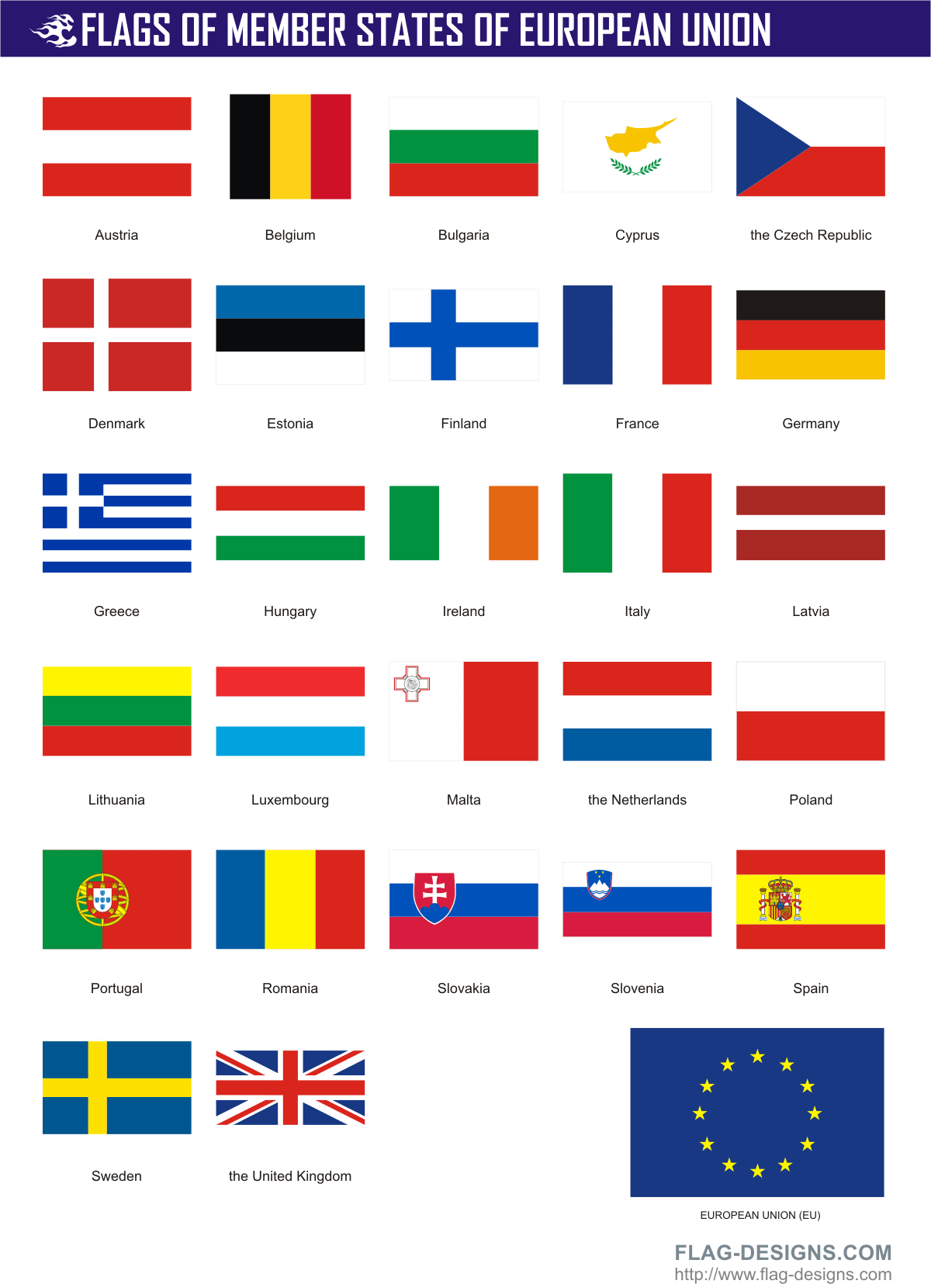

Group Task:
There are currently five candidate countries for EU accession (i.e. countries who are in negotiations to join the EU): Croatia, Iceland, the former Yugoslav Republic of Macedonia, Montenegro and Turkey.
Produce a short advertisement promoting the benefits to the accession countries of joining The European Union and adopting the Euro as their national currency.
Possible promotional methods include:
- A website
- An interactive PowerPoint (clickable hyperlinks)
- A leaflet or detailed poster
- A TV advert (scripted, animated and/filmed)
*****You have two lessons to complete and present your promotion*****

