Measuring Living Standards using Disposable Incomes
Households in the UK had £1,006 billion in gross disposable household income (GDHI) in 2011, or £16,034 per person.
GDHI is the amount of money available for spending or saving after income distribution measures (taxes, social contributions and benefits, etc.) have taken effect.

Chart 1: GDHI per person growth on previous year, 2009, 2010 and 2011

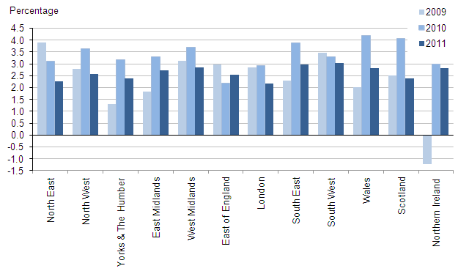
Look at the Chart above and pick out two significant features from the data. Back up your points using dates and figures from the Chart.

Chart 2: GDHI per person 2011 by region
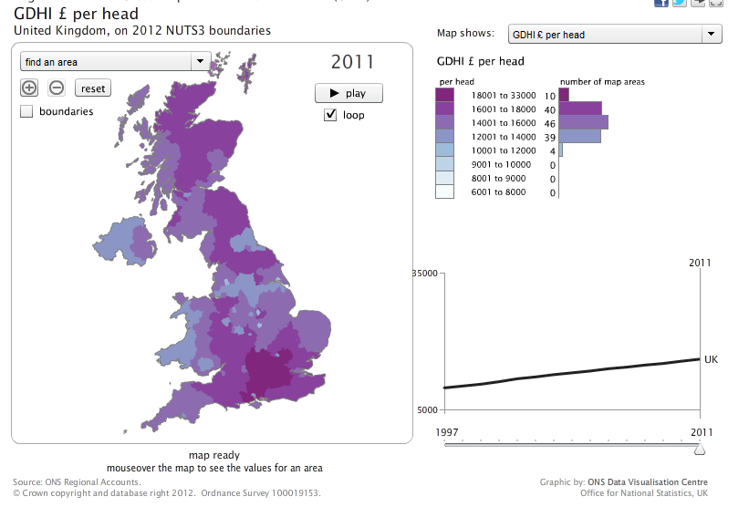
Whilst Chart 1 illustrates percentage changes in disposable incomes, the map opposite shows the actual disposable incomes by region.
Remember that in 2011 the average gross disposable household income was £16,034.
Click on the map opposite to load the interactive map and complete the task below!

Look at the Chart above and pick out two significant features from the data. Back up your points using figures and statistics from the Chart.

