Unit 11 Personal Economics:   
further guidance using the Jan 2011 past paper

Remember me!? The information below will help you with your exam technique but remember that you have an **exam guide** with more detailed advice!

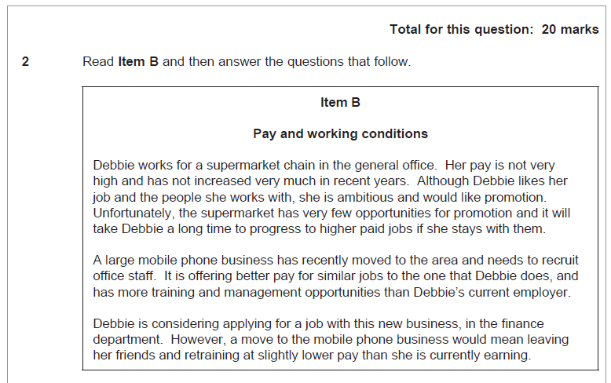

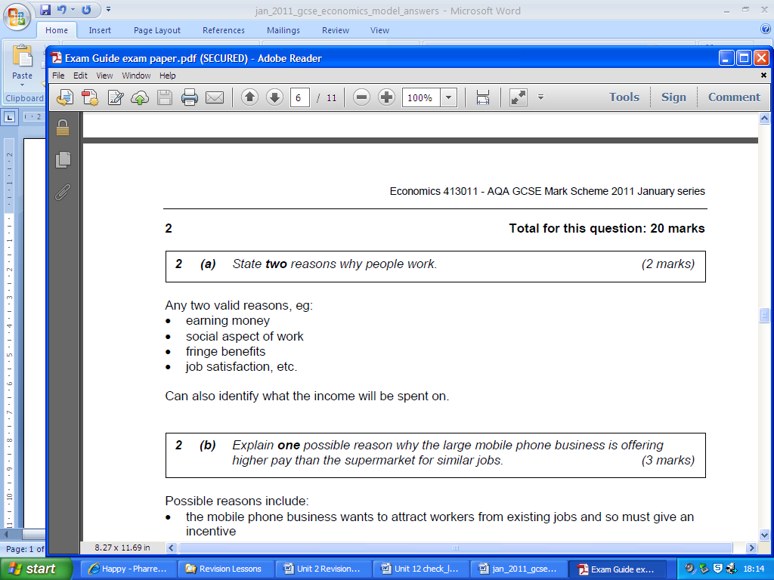

Identify questions need technical responses in terms of the terminology that you use. They will be related to the case study i.e. Debbie is thinking of leaving for higher pay. Don’t use this context yet. **TECHNICAL TERMS ONLY** !!!!!!!!

- Earn money  
- Social aspect of work



The mobile phone business has “only recently moved to the area”. This means they may need to “offer better pay for similar jobs” **because** they need to provide an incentive for people like Debbie to leave their existing job at the supermarket and move to them. **This is important because** if people don’t apply they will struggle to complete their business activities.

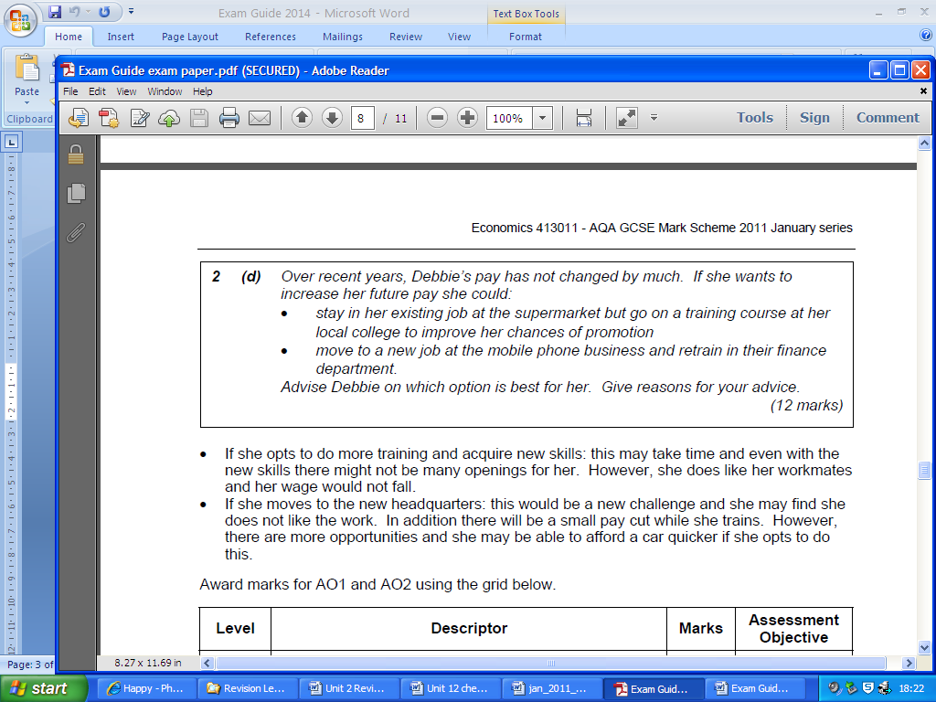

I believe that Debbie should move to a new job at the mobile phone business and retrain in their finance department.

Essay Writing Frame

An advantage of moving to the new job at the mobile phone business and retrain in the finance department is that she’ll be doing her training on the job. This is important because it will not incur the same time pressures that the college course does as she’ll be training while at work. A disadvantage is that her pay will actually be lower than what she is currently earning during this training period. This is important because if she is already thinking of moving due to her pay, then earning even less may impact her ability to pay for her basic needs like accommodation.

An advantage of staying in her existing job at the supermarket and train at local college is that this means that she can continue to work alongside her current friends/colleges. This is important to Debbie as she likes her friends and the people that she works with. This to some extent will make up for lower pay. If she cannot obtain this from her new job then she may feel worse off even though she’ll be earning more. A disadvantage of staying in her existing job at the supermarket and train at local college is that the super market has very few opportunities for promotion. This is important because even if Debbie puts the time and effort into the college course it does not guarantee that she’ll obtain a promotion so her pay will stay the same, even though she would of paid for the college course.

Feedback

To evaluate, in my opinion, I believe that Debbie should move to the mobile phone business. What draws me to this conclusion is that she is ambitious and wants promotion. Therefore although she likes her job at the moment she may find it boring if it remains the same with little opportunity for progress. The mobile business offers the opportunity to train that she may enjoy as well as promotion which she seeks. Therefore in the long run she’ll be financially better off in a new job she’ll find rewarding as it requires the use of the new skills she has learnt. Although she’ll miss her work colleges, all workers will be new at the mobile business so it should be easy to make new friends when training and in the finance department. She can still see her friends from the supermarket in a non-work environment. This means the net advantages of this option outweigh staying at the supermarket as she’ll be getting more benefits from working in the mobile phone business.

Task: Identify an appropriate writing frame for the extended essay questions like I’ve done with 2d.

Using the mark scheme give my answer a level for analysis, evaluation and structure; as well as a final total.