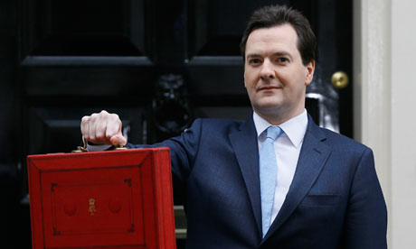

Using two examples **describe** of how economic objectives may conflict with each other;

A budget deficit is --  
  
  
A budget surplus is --

**State** the main methods of measuring economic performance.

1.

2.

3.

4.

**State** the 4 main government economic objectives:

1.

2.

3.

4.

Explain what is meant by;

1. Equity:

2. Equality:

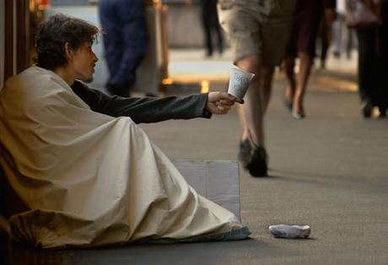

Issues of equity and equality are directly linked to the government’s economic objectives and policies

How might ethical issues affect the achievement of these government objectives?

|  |  |
| --- | --- |
| Benefits of the welfare state | Costs of the welfare state |
|  |  |
|  |  |
|  |  |

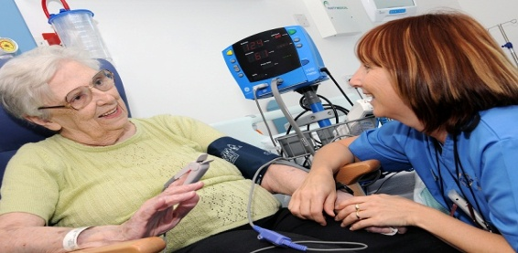

I think economic growth is bad because…

I think economic growth is good because…

The **welfare state** refers to the different forms of benefits and services provided for those in need of support. This support can be both practical (e.g. training) and financial (e.g. working tax credits).

State 4 possible alternatives/changes to the welfare state

1.

2.

3.

4.

The UK coalition government are making significant changes to the welfare state e.g. ‘universal benefits’, ‘benefits cap’

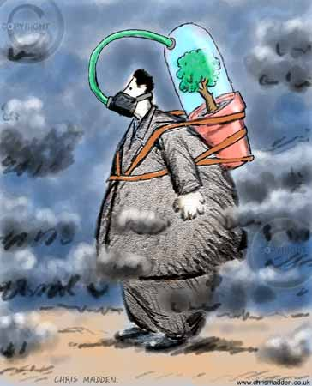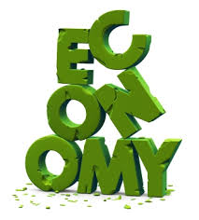

**Market Failure** occurs when markets fail to allocate resources efficiently.

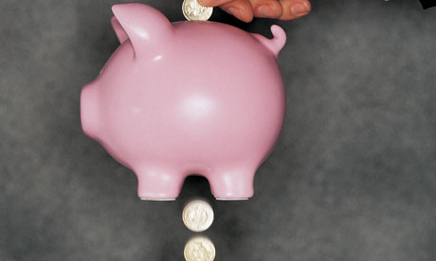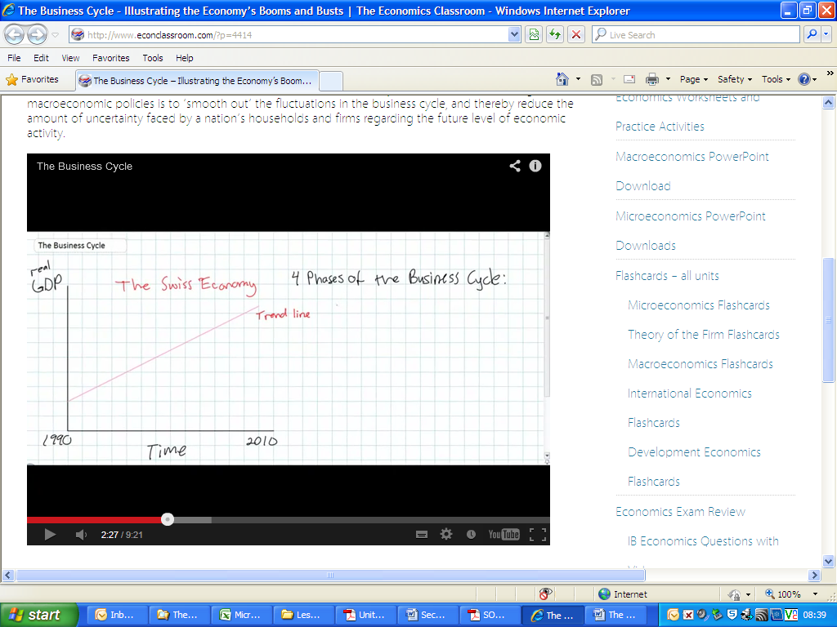

Mixed economies: this type of economy works similarly to a free-market economy but the government participates and intervenes in certain markets.

**Externalities** exist when there is a difference between   
 social costs (benefits) and private costs (benefits) from the consumption or production of a good or service.

Free-market economies: under this system economic activity occurs through private business and individuals.

UK Govt. Budget

The UK Economy

Negative and positive Externalities

Identify the top 3 sources of government revenue (income).

1.

2.

3.

Identify the top 3 items of government expenditure (spending).

1.

2.

3.

State the main 4 stages in the economic cycle.

1.

2.

3.

4.

State 5 differences between free market economies and mixed economies.

1.

2.

3.

4.

5.

There are two main types of economies a country may have;  
 1. **Free-market**   
 2. **Mixed economies**

Developed economies such as the UK tend to have mixed economies.

#

|  |  |  |  |
| --- | --- | --- | --- |
| http://www.thetoolkit.net/graphics/toolkit_large_login.gif  Economic objective/indicator | [http://t0.gstatic.com/images?q=tbn:ANd9GcQbg_nw_ZFs0Wy3LmRv9p1BjuOydRCQO_JpInURyDE8kRUpS0gkdxZw4w:cdn.newsthump.com/wp-content/uploads/2010/10/child-benefit-money.jpg](http://www.google.co.uk/imgres?imgurl=http://cdn.newsthump.com/wp-content/uploads/2010/10/child-benefit-money.jpg&imgrefurl=http://newsthump.com/2010/10/05/hang-on-we-get-benefits-ask-nations-children/&usg=__JzZItRJuvtZ6AuXT2k_y6bDCib4=&h=172&w=228&sz=13&hl=en&start=1&zoom=1&tbnid=ZUEsetcrBImbmM:&tbnh=81&tbnw=108&ei=bFduUe74FaeP0AWVmoH4Dw&prev=/search?q=child+benefit&um=1&safe=vss&biw=1024&bih=600&hl=en&sout=1&tbm=isch&um=1&itbs=1&sa=X&ved=0CCwQrQMwAA)[http://t1.gstatic.com/images?q=tbn:ANd9GcQgs_Bpwwv9-PA8dig_WjzHKdIuLu1Wo2PlpXUaxOhROtoeJb542k_Njws1:thebackbencher.co.uk/wp-content/uploads/2013/02/Cut-Taxes-e1349383801752.jpg](http://www.google.co.uk/imgres?imgurl=http://thebackbencher.co.uk/wp-content/uploads/2013/02/Cut-Taxes-e1349383801752.jpg&imgrefurl=http://thebackbencher.co.uk/osborne-must-be-bold-with-spending-cuts-tax-reductions/&usg=__H6q9fMcFqLMtz0BgNiizyDF0iX0=&h=608&w=600&sz=43&hl=en&start=14&zoom=1&tbnid=2Qjhvr256WBtbM:&tbnh=136&tbnw=134&ei=NFduUbjTKKX80QWLsYHwDA&prev=/search?q=taxes&um=1&safe=vss&biw=1024&bih=600&hl=en&sout=1&tbm=isch&um=1&itbs=1&sa=X&ved=0CEYQrQMwDQ)  Fiscal Policy | http://www.tutor2u.net/blog/files/interest_rates.gif  Monetary Policy | http://t0.gstatic.com/images?q=tbn:ANd9GcT2JzI3W0GzPU25oyULet2lmg1RG8qCp8JWk0NFrewF38E2oGyoMAsgyA:www.gopromotional.com/blog/media/gopromotional_competion.jpghttp://www.sfcc.edu/sfcc/img/1170.jpg  Supply-side Policies |
| Economic Growth (High & Sustainable) |  |  |  |
| The government has three main **Economic Policies** to control the economy  1. **Fiscal Policy**   2. **Monetary Policy**  3. **Supply-side Policies**  The UK government uses a combination of all three policies to help it achieve its economic objectives.  Stable Prices  (Low inflation) |  |  |  |
| Balance of Payments (Trade Balance or small surplus) |  |  |  |
| Unemployment  (Low rates) |  |  |  |

**Monetary Policy** refers to the changes in the interest rate set by the BOE.

**Supply-side Polices** cover a range of government programmes from education and training schemes, improving incentives to work, to competition policy.

**Monetary Policy** refers to the changes in the interest rate set by the BOE.

**Fiscal Policy** refers to the changes in government spending and taxation.

|  |  |
| --- | --- |
| **Advantages of EU Membership** | **Disadvantages of EU Membership** |
|  |  |
|  |  |
|  |  |

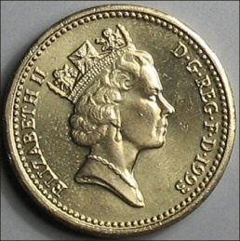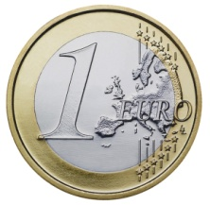

Adopting the Euro would be **bad** for the UK because…

Adopting the Euro would be **good** for the UK because…

Give me 5 important facts about the European Union (EU).

1.

2.

3.

4.

5.

[](http://www.google.co.uk/imgres?imgurl=http://us.123rf.com/400wm/400/400/grafvision/grafvision1209/grafvision120900902/15348825-portrait-of-young-man-thinking-against-a-white-background.jpg&imgrefurl=http://www.123rf.com/photo_15348825_portrait-of-young-man-thinking-against-a-white-background.html&usg=__lK632qC5iI_DkL_NIdlhYKxhuSE=&h=1200&w=939&sz=124&hl=en&start=100&zoom=1&tbnid=NSc3paLApdcElM:&tbnh=150&tbnw=117&ei=n2FuUdGLI6340gXPn4G4Bw&prev=/search?q=thinking+man&start=80&um=1&safe=vss&sa=N&biw=1024&bih=611&hl=en&sout=1&tbm=isch&um=1&itbs=1&sa=X&ved=0CFIQrQMwEzhQ)

[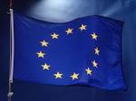](http://www.google.co.uk/imgres?imgurl=http://eeas.europa.eu/delegations/azerbaijan/images/content/euroepan_union_flag_hanging.jpg&imgrefurl=http://eeas.europa.eu/delegations/azerbaijan/more_info/faq/index_en.htm&usg=__xC3qQbGYKhI3vxi4D-PcBfix8lc=&h=1819&w=2445&sz=243&hl=en&start=13&zoom=1&tbnid=m9Fb19LRD-gcPM:&tbnh=112&tbnw=150&ei=32FuUaOOAebI0QWHm4HYDw&prev=/search?q=the+european+union&um=1&safe=vss&biw=1024&bih=611&hl=en&sout=1&tbm=isch&um=1&itbs=1&sa=X&ved=0CEQQrQMwDA)

**EU Enlargement refers to the process of accepting new member countries into the EU.**

[](http://www.google.co.uk/imgres?imgurl=http://ec.europa.eu/enlargement/images/reports.jpg&imgrefurl=http://ec.europa.eu/enlargement/countries/strategy-and-progress-report/&usg=__gopDaIJwXyKD5anBdFKcba7i-3k=&h=2848&w=4288&sz=1639&hl=en&start=15&zoom=1&tbnid=2OkYIBIwOdfqLM:&tbnh=100&tbnw=150&ei=kmJuUZSmCInE0QXwtICgBQ&prev=/search?q=eu+enlargement&um=1&safe=vss&biw=1024&bih=611&hl=en&sout=1&tbm=isch&um=1&itbs=1&sa=X&ved=0CEoQrQMwDg)

Explain 3 important effects of EU Enlargement on existing member countries.