Externalities

Negative Externalities
Social Costs
(Total costs to society of an economic activity)
External Costs
(Spill-over costs to third parties)
Private Costs
(these are the costs to individual consumers or firms of an economy activity)

Task 1: Can you identify the private and external costs associated with the following?
Economic Activity/Incident | Private Costs | External Costs
Binge drinking of alcohol (consumption)  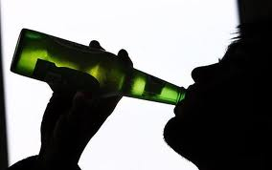 | - The price of alcohol that the consumer pays  - The negative health effects of heavy binge drinking e.g. liver disease  - Lost income due to ill health which results in long-term absence  - Breakdown of personal relationships as a result of the financial expense, ill-health and ‘unsocial’ nature of binge drinkers | - The latest figures indicate that binge drinking costs the NHS £2.7bn a year; (note: the NHS is funded by the general taxpayer through NIC)  - Increased policing is required to manage and control the negative effects of binge drinking  - Those individuals who are intoxicated tend to be unsocial, causing noise, violence and general crime
Driving (consumption)

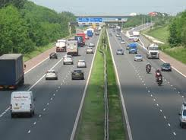

The mining and production of crude oil by companies such as British Petroleum (BP) (production)
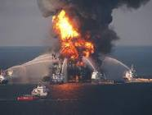
Your own idea

Positive Externalities
Private Benefits
(these are the benefits to individual consumers or firms of an economy activity)
Social Benefits
(Total benefits to society of an economic activity)
External Benefits
(Spill-over benefits to third parties)

Task 2: Can you identify the private and external benefits associated with the following?

Economic Activity | Private Benefits | External Benefits
Further Education (consumption)

Healthy Living/Eating (consumption)

Product research/development (production)

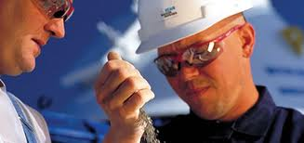

Your own idea

