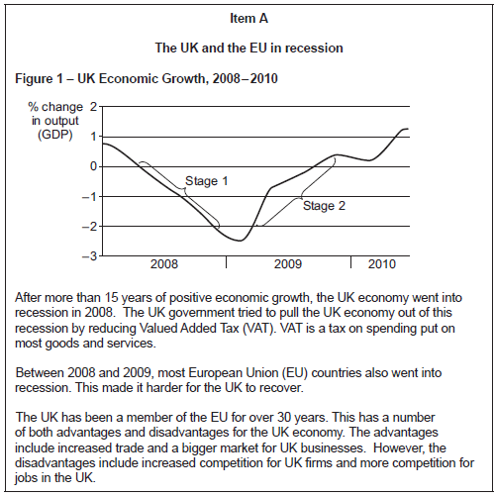

Extended Essay Plan

Mini-judgement =

Analysis & evaluation points

1. Agree

2. Disagree

Final judgement & justification points

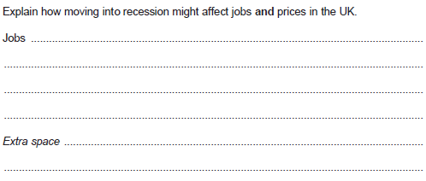

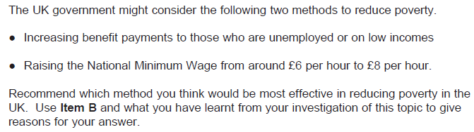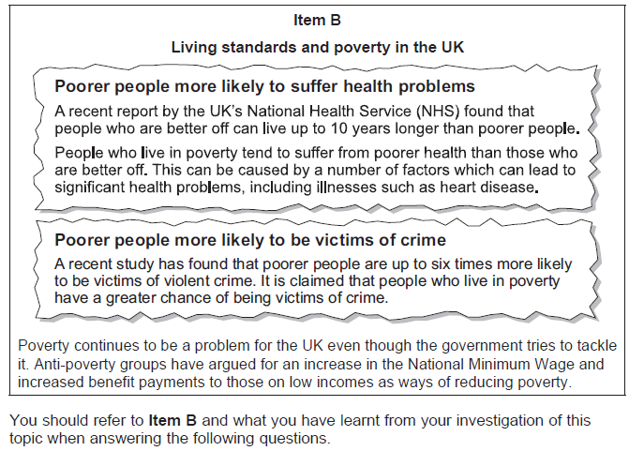

Extended Essay Plan

Mini-judgement =

Analysis & evaluation points

1. Increasing unemployment and low income benefits

2. Raising the NMW

Final judgement & justification points

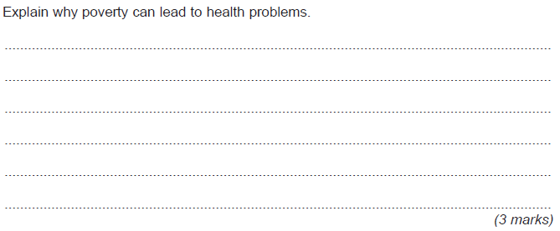

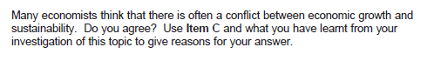

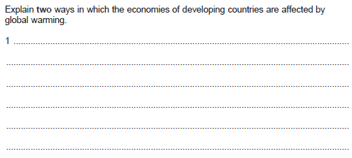

Extended Essay Plan

Mini-judgement =

Analysis & evaluation points

1. Agree

2. Disagree

Final judgement & justification points