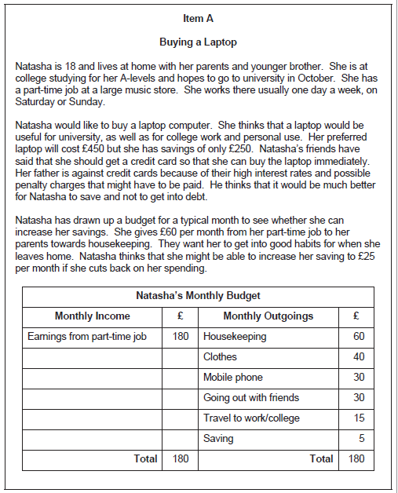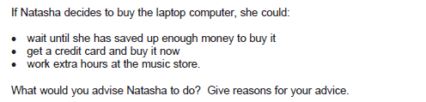

Extended Essay Plan

Mini-judgement =

Analysis & evaluation points

1. Wait until she has saved up enough money to buy it

2. Get a credit card and buy it now

3. Work extra hours at the music store

Final judgement & justification points

   
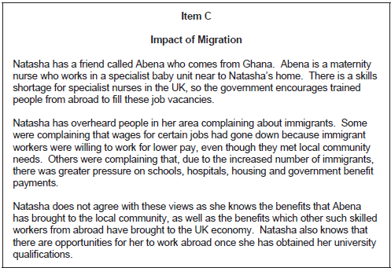

Extended Essay Plan

Mini-judgement =

Analysis & evaluation points

1. Arguments for migration of workers into the UK

2. Arguments against migration of workers into the UK

3. Arguments for migration of workers out of the UK

4. Arguments against migration of workers out of the UK

Final judgement & justification points





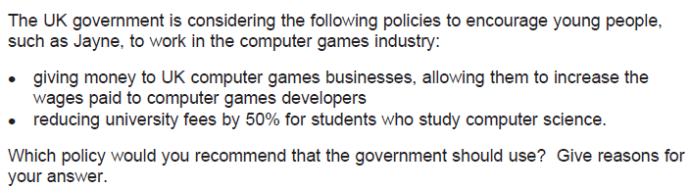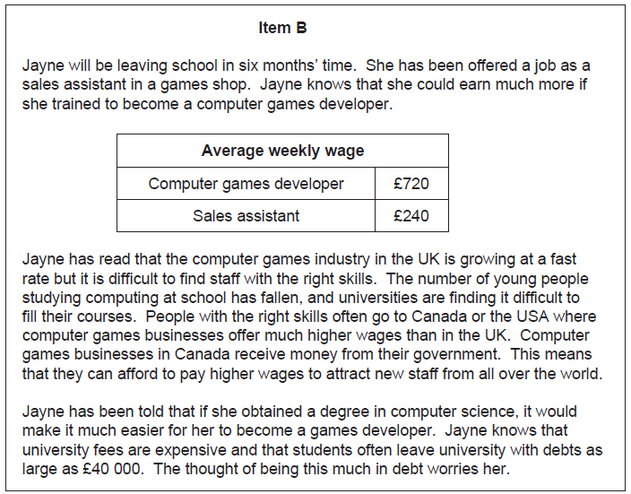

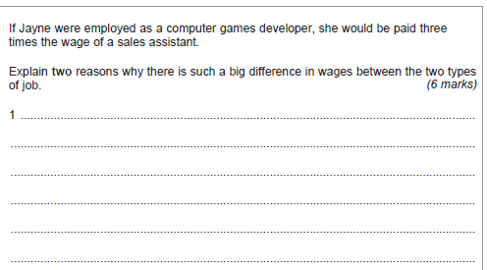

Extended Essay Plan

Mini-judgement =

Analysis & evaluation points

1. Government subsidy to increase wages

2. Reduction in university fees

Final judgement & justification points