

**GCSE Economics**

**Name**: ___________________

**Teacher**: Mr Tarn

**Business, Information Technology and Enterprise**



**Contents**

Introduction 2

Exam Specifics 3

Exam Questions

* + Case Study Items 4
  + Stating and identification questions 5
  + Explanation Questions 6
  + Analytical and evaluative questions 8

Practice Exam Questions 12

Useful Websites 21



**1. Introduction**

**Introduction**

Well done on completing Unit 12, Investigating Economic Issues. This unit has further developed your understanding of economic concepts and theories studied in Unit 11; applying what you have learnt to a range of economic issues locally, nationally and globally.

This exam guide will analyse the various aspects of the exam and provide opportunities for you to practice and improve upon your examination technique.

Hello again Young Economist! This guide will provide you will all you need to know about the Unit 12 exam; with a few hints and tips from me you will improve your exam technique.



**2. Exam Specifics**

**Examination details**

Remember that time is tight in the exam! Try to spend one minute per mark on questions – therefore most of your time should be spent on the final questions in each of the three sections in the exam!

Paper: Unit 12: Investigating Economic Issues

Date: Tuesday 3rd June 2014

Time: PM



Length: 75 minutes

Marks available: 70 marks

Additional Info:

* Answer all questions
* The marks for questions are shown in brackets.
* You are reminded of the need for good English and clear presentation in your answers, as you will be assessed for the quality of Written Communication
* Don’t write outside the boxes/space provided
* Questions 2 and 3 are based on the economic issues you have investigated before this examination.

**Exam Structure**

The marks for the three sections are roughly the same (i.e. a third of the total marks each) and may change based on the exam.

The exam is split up into 3 sections

1. Managing the Economy (24 marks)
2. Poverty (22 marks)
3. Global Warming (24 marks)

**How you will be assessed**

In each of the 3 sections questions will assess your ability to…

1. *Recall, select and communicate* their knowledge and understanding of concepts, issues and terminology (20 out of 70 marks).

2. *Apply skills, knowledge and understanding* in a variety of contexts (25 out of 70 marks)

3. *Analyse and evaluate* evidence, make reasoned judgements and present appropriate conclusions (25 out of 70 marks)



**3. Exam Questions: Case Study Items**

Each section of the exam paper covering *Managing the Economy, Poverty* and *Global Warming*, starts with a short Case Study Item such as the example below;

**Total for this question: 26 marks**

**Managing the Economy**

1. Read **Item A** and then answer the questions that follow.

Just like Unit 11 it’s important to read & highlight the case study!

**Item A**

**‘A period of economic failure?**’

|  |  |  |  |
| --- | --- | --- | --- |
| Year/Quarter | Inflation Rate (%) | Unemployment Rate (%) | GDP Growth (%) |
| 2011/1 | 4.0 | 7.9 | 0.5 |
| 2011/2 | 4.2 | 8 | 0.1 |
| 2011/3 | 5.2 | 8.3 | 0.6 |
| 2011/4 | 3.6 | 8.2 | -0.1 |
| 2012/1 | 3.5 | 8.1 | -0.1 |
| 2012/2 | 2.4 | 7.9 | -0.4 |
| 2012/3 | 2.2 | 7.8 | 0.9 |
| 2012/4 | 2.8 | 7.8 | -0.3 |

Over the past 4 to 5 years the UK economy has experienced a period of considerable economic turmoil. Indicators have been increasingly poor and World and European events have damaged the UK economy. Whilst the Bank of England can use interest rates to help control the economy, the UK government has both fiscal and supply-side policies at its disposal to help them influence UK economic performance.



You need to use the information from the case study throughout your answers to all questions in the exam – those students who **fail** to do this **will drop a lot of marks**!

**4. Exam Questions: State & Identify**

After the Case Study Item you are asked a series of *related* questions in each section.

The first question for Managing the Economy will ask you to **state** or **identify** something (see example below). Ensure you read the questions carefully and write in full sentences, checking your spelling and grammar.

**1** (a) (i) State **two** methods of measuring the performance of the UK economy other than those highlighted in Item A.

...........................................................................................................................................................................................................................................................................................................................................................................................................................................................................................................................................................

.......................................................................................................................................

(2 marks)



Whilst there may be a number of possible answers to questions like the example above it’s important that your answer is direct –**don’t be vague in your answer!**



**5. Exam Questions: Explain**

The next question in the Section for Managing the Economy and the first question in the Section for Poverty and Global Warming, will ask you to **explain/describe** something (sometimes state and explain something). These explanation questions require you to apply your *skills, knowledge and understanding* in **context**.

**1** (a) (ii) Using two of the indicators highlighted from **Item A**, describe how the UK economy has performed over the given period.

Indicator 1: .....................................................

...........................................................................................................................................................................................................................................................................................................................................................................................................................................................................................................................................................

.....................................................................................................................................................................................................................................................................................................................................................................................................................

Indicator 2: .....................................................

...........................................................................................................................................................................................................................................................................................................................................................................................................................................................................................................................................................

.....................................................................................................................................................................................................................................................................................................................................................................................................................

(4 marks)

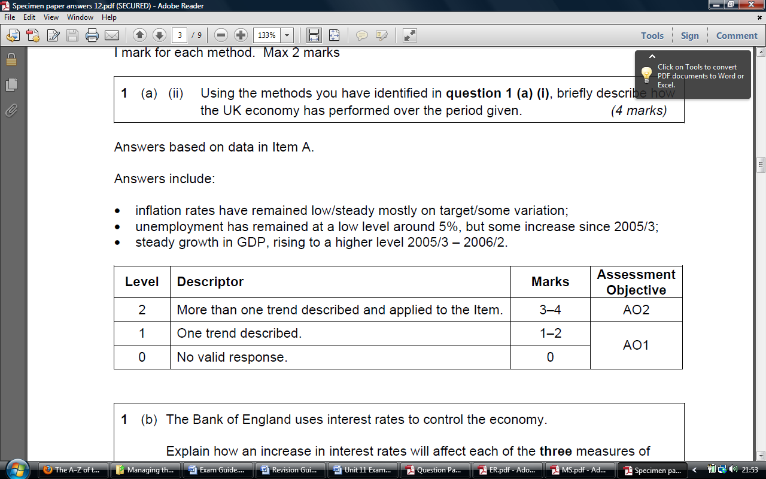



**This is the marks scheme for this question. If you are too brief in your description or don’t apply your answer to the context you will drop marks! Remember to refer to specific years/quarters in your answer!**

There are usually two or three *explanation* questions in each section, which increase in complexity and in terms of the number of marks available. These questions tend to include some extra information in addition to the Case Study Item (see examples below).

**1** (b) The Bank of England uses interest rates to control the economy. Whilst inflation appears to be returning to target levels, economic growth is stalling and unemployment remains relatively high. The Bank of England would normally reduce interest rates to stimulate the economy however at a rate of 0.5% it is at an all time low.

Explain how fiscal policy can be used to affect each of the **three** measures of performance in **Item A**.

...........................................................................................................................................................................................................................................................................................................................................................................................................................................................................................................................................................

...........................................................................................................................................................................................................................................................................................................................................................................................................................................................................................................................................................

...........................................................................................................................................................................................................................................................................................................................................................................................................................................................................................................................................................

...........................................................................................................................................................................................................................................................................................................................................................................................................................................................................................................................................................

..............................................................................................................................................................................................................................................................................

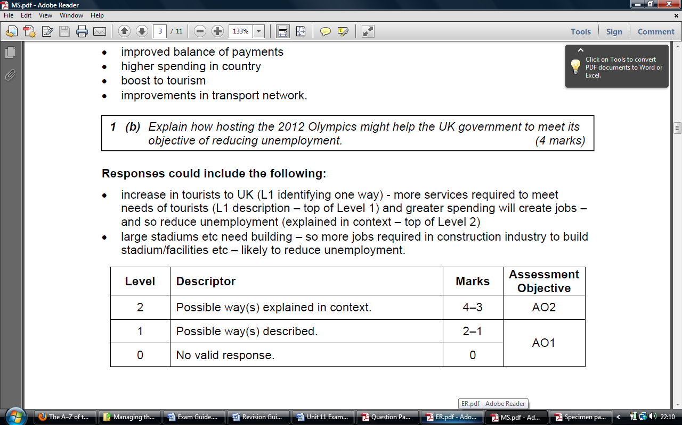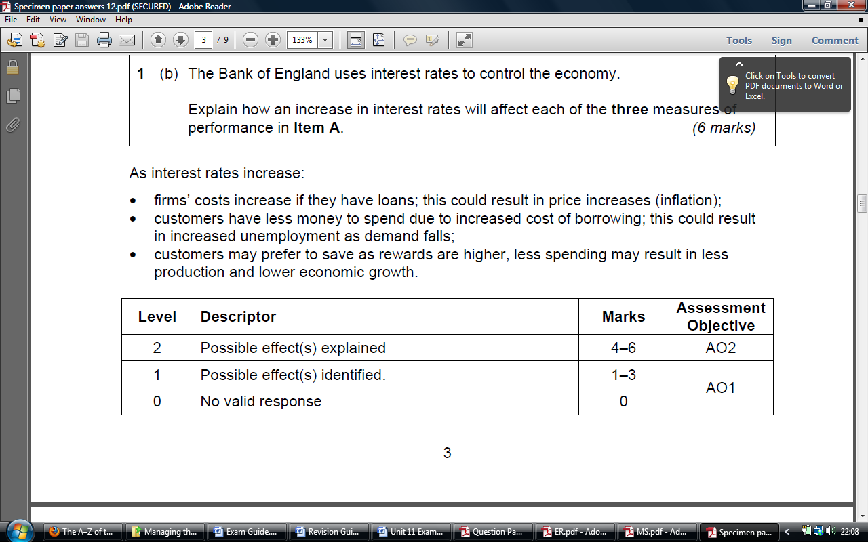(6 marks)

Examiners are looking for a **logical chain of explanation** in context – look at the marks scheme and answer this question!



  
The final question in each section of the exam paper will be fairly open where you can demonstrate your understanding of the topic(s) from your investigation and research. The best candidates are the ones that **analyse** their points in detail and **evaluate** their ideas as they go along, coming to a **reasoned judgement** at the end.

**6. Exam Questions: Analyse & Evaluate**

The *Chief Examiner* in his comments on the last Unit 12 exam said the following...”*The very best responses were clearly organised answers which offered clear judgement and justification..., often ‘weighing up’ the strength and significance of key factors and/or distinguishing between short/long run effects. Some slightly weaker approaches saw students begin with a bold conclusion which was then contradicted in the body of the answer.”*

Below is an example of the type of question you will find at the end of each section of the exam paper. It usually includes some extra information to add to the Case Study Item, as is the case here.

Before answering the question below have a look at how it is marked by the examiner on page 11 and 12!

**1** (c) The UK Coalition Government has put reducing the government’s budget deficit at the top of its agenda; cutting government spending, rather than increasing taxes in order to achieve this. However with poor recent figures for economic growth and unemployment many opponents to this economic policy have called for a change in strategy.

Recommend a strategy you would use to achieve high and sustainable economic growth, low unemployment, stable prices and a balance of payments surplus. Give reasons to justify your strategy.

...........................................................................................................................................................................................................................................................................................................................................................................................................................................................................................................................................................

..............................................................................................................................................................................................................................................................................

.............................................................................................................................................................................................................................................................................

...........................................................................................................................................................................................................................................................................................................................................................................................................................................................................................................................................................

...........................................................................................................................................................................................................................................................................................................................................................................................................................................................................................................................................................

..............................................................................................................................................................................................................................................................................

...........................................................................................................................................................................................................................................................................................................................................................................................................................................................................................................................................................

...........................................................................................................................................................................................................................................................................................................................................................................................................................................................................................................................................................

...........................................................................................................................................................................................................................................................................................................................................................................................................................................................................................................................................................

...........................................................................................................................................................................................................................................................................................................................................................................................................................................................................................................................................................

..............................................................................................................................................................................................................................................................................

...........................................................................................................................................................................................................................................................................................................................................................................................................................................................................................................................................................

The best answers are often those which present a balanced argument, where analysis and evaluation covers both sides/aspects of an issue, but where the student persuades the examiner in their viewpoint!

..............................................................................................................................................................................................................................................................................

(14 marks)

(Extra space).................................................................................................................  
............................................................................................................................................................................................................................................................................................................................................................................................................................................................................................................................................................

............................................................................................................................................................................................................................................................................................................................................................................................................................................................................................................................................................

Add a clear final judgement paragraph where you come to a decision, readdressing the question – remember that your analysis and evaluation needs to support this judgement and vice versa – do not have conflicting judgements with the rest of your answer!

These questions are worth 12 or 14 marks in each of the three sections. It’s therefore very important that you answer these questions well.

In these questions you are also assessed on the **quality of your written communication** (see tips below).

2. Your answer should have a clear structure; include a **final judgement paragraph!**

1. Try to use economic terms and language throughout your answers (use the term ‘unemployed’ and not ‘jobless’) – writing a glossary of key terms should help you with this!

3. Check that you have referred to the Item (context) throughout your answer.

4. Write in **paragraphs** for each new point. Use correct conventions for punctuation (capital letters and full stops)

7. Ensure you answer the question directly – veer off course and you drop marks!

5. Use correct conventions for punctuation (capital letters and full stops)

6. Use the full width of you page – do not write outside the boxes; if you need extra space ask for an AQA supplementary answer book.

The examiner responsible for marking your paper will read your answer to the final question thoroughly.

The first step they will take is to decide on a level based on your answer. If for example you apply your knowledge to analyse the different options to the UK government to control he economy (i.e. in context) you will achieve a Level 3, recording 5 to 6 marks depending on the quality of your answer.

|  |  |  |  |
| --- | --- | --- | --- |
| **Level** | **Descriptor** | **Marks** | **Assessment Objective** |
| L3 | Analyses and applies knowledge of the different option(s) to the Coalition Government | 5-6 | AO3 |
| L2 | Describes features of the different options. | 3-4 | AO2 |
| L1 | Basic understanding of the option(s) is/are demonstrated. | 1-2 | AO1 |
| L0 | No valid response. | 0 |

The next step the examiner will take is to assess both the quality of your written communication, as well as your a*nalytical and evaluative skills* to make reasoned judgements and present appropriate conclusions (i.e. Assessment Objective 3)

When deciding on the level to be awarded for Assessment Objective 3, they will consider the degree to which you order, structure and communicate your ideas. You need to be aiming for Level 2 (i.e. E2) to achieve top marks (see below).

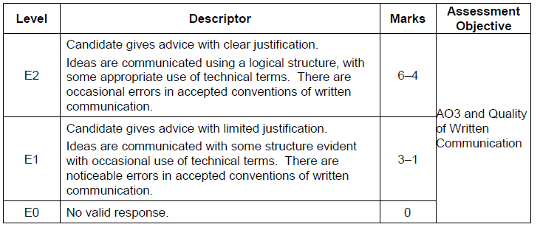



**7. Practice Exam Questions**

Using the guidance which has been given so far, answer the questions for final two sections of the exam on **Poverty** and **Global Warming**.

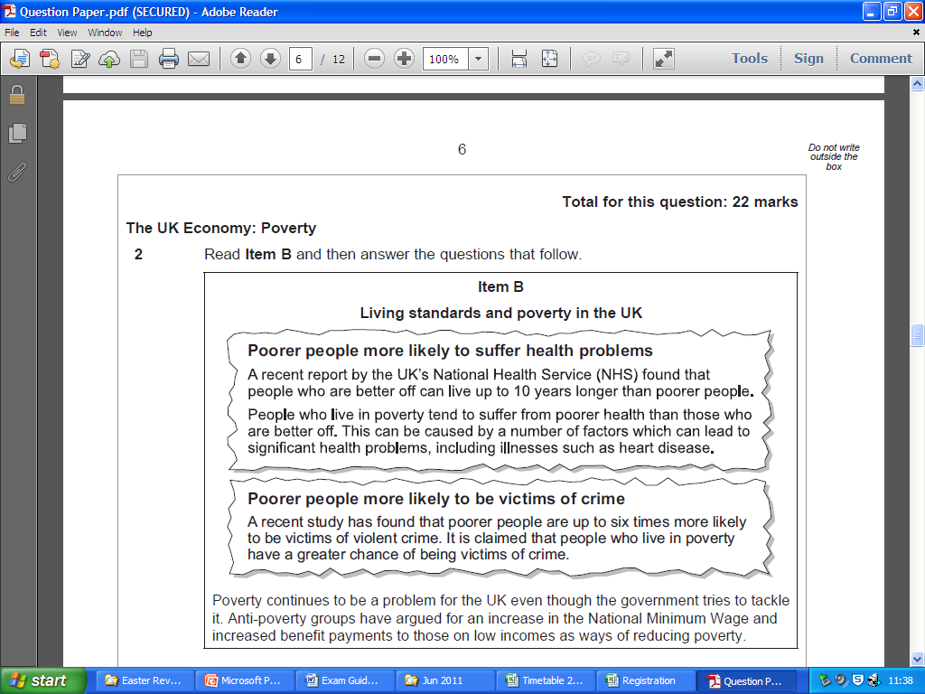

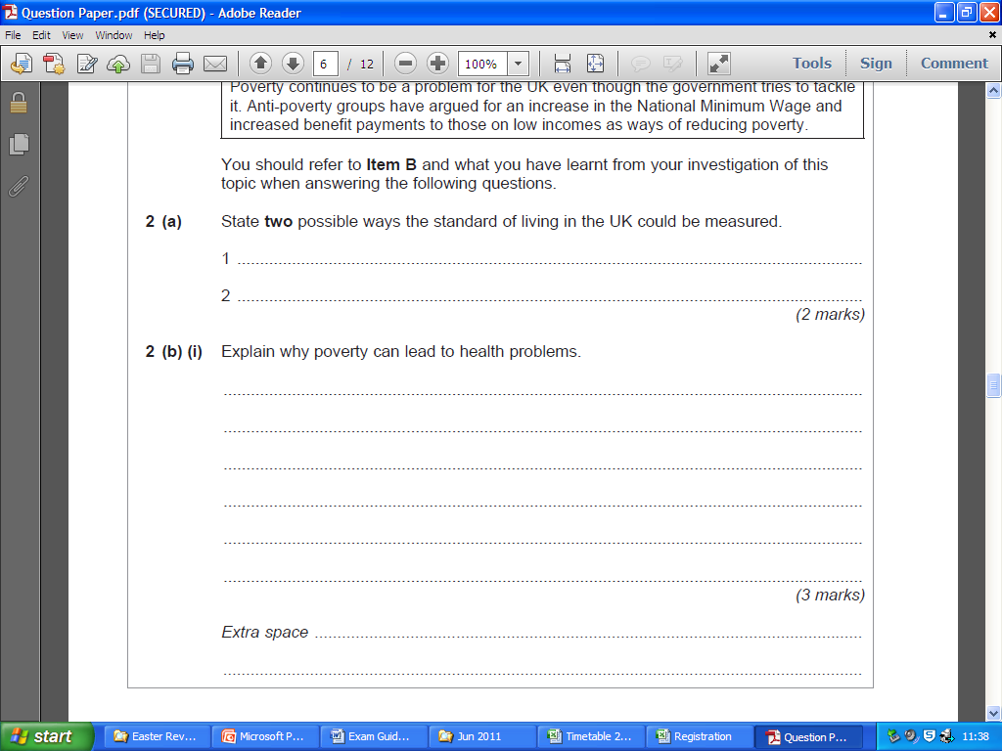

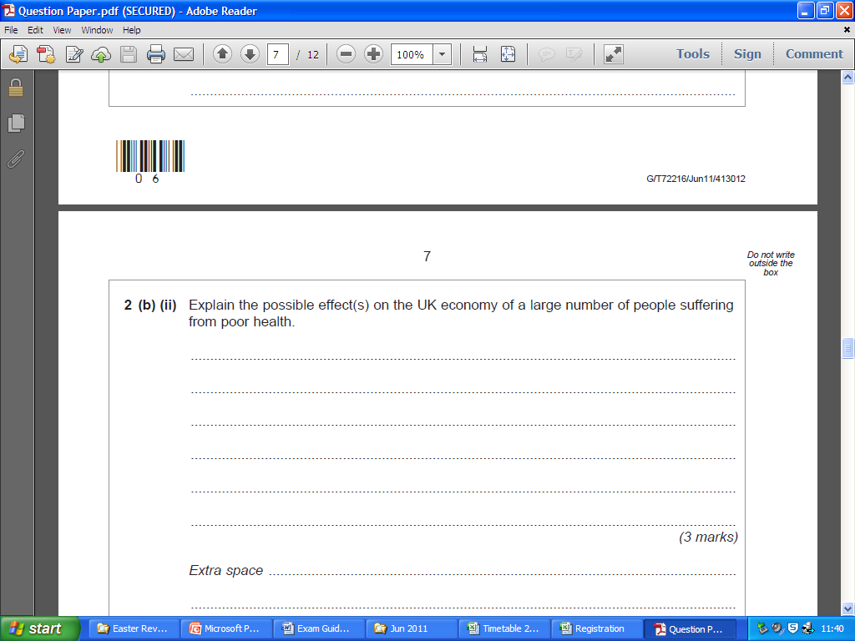

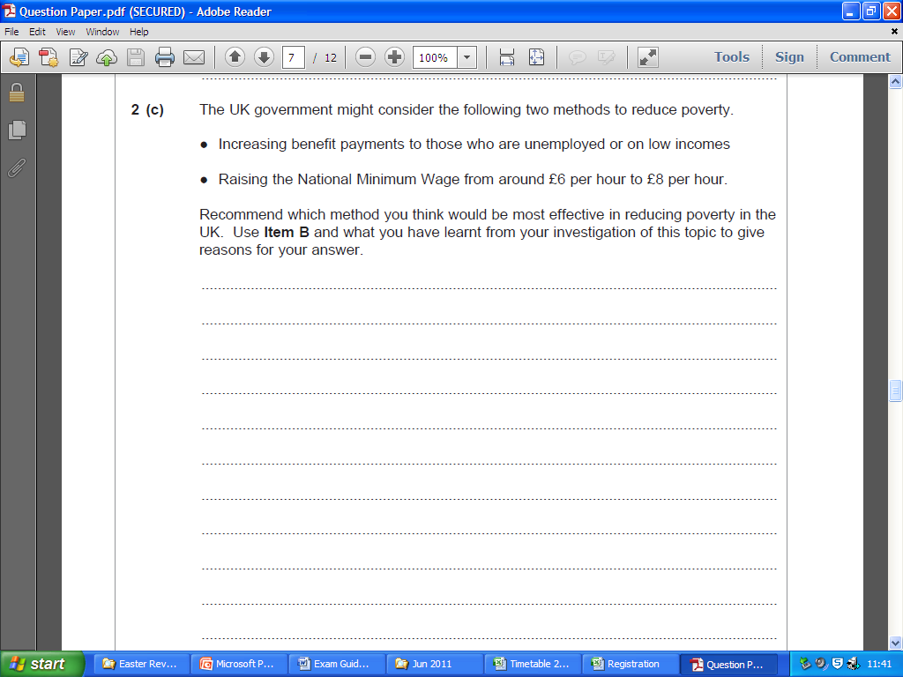



Use the information from **Item B** and your own **research** – remember to analyse and evaluate **both methods**; **not** just your preferred one!





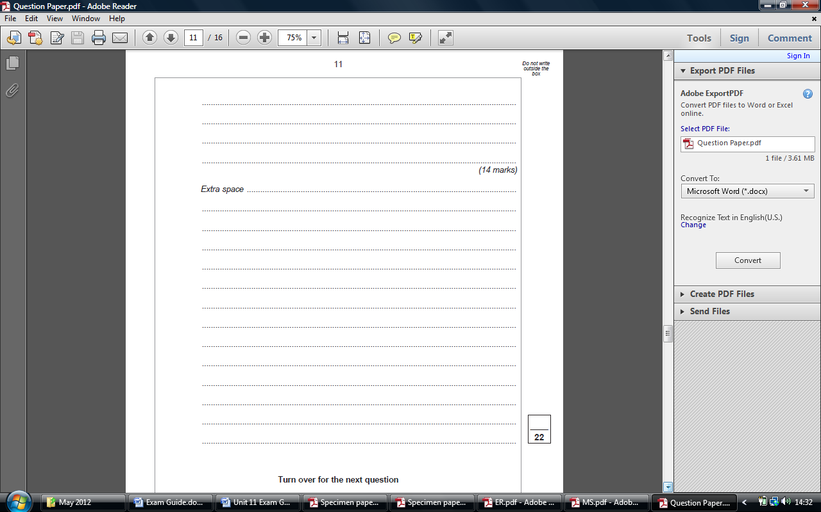

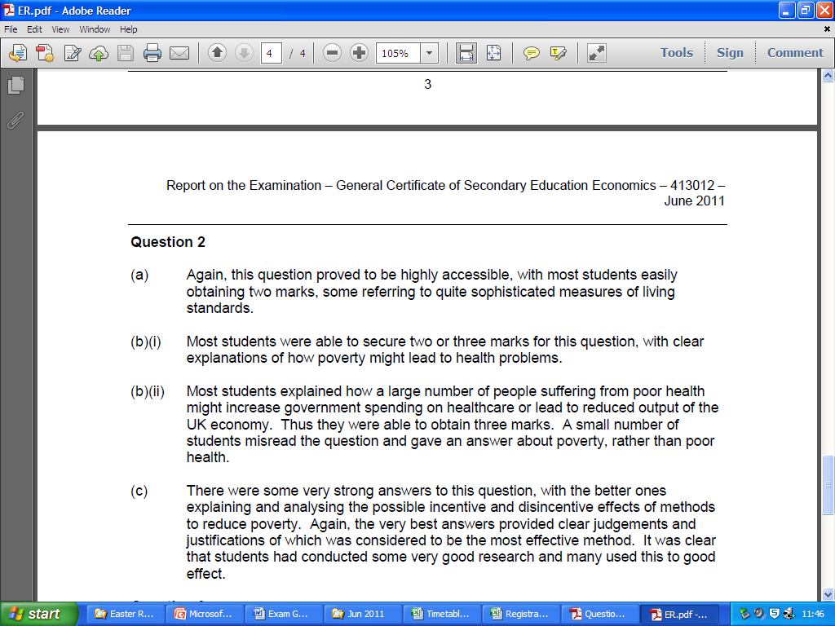



This is what the Chief Examiner said about students answering the above question – use it to help you write your own answer!

**The Global Economy: Global Warming**  Total for this question: 24 marks

3. Read **Item C** and then answer the questions that follow.

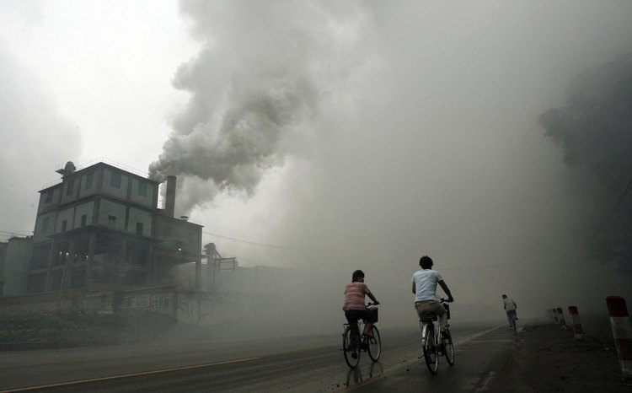**Item C**

**Global Warming, a global issue requiring a global solution!**

Source: Cyclists passing a factory emitting pollution in Beijing, China, Getty Images

**Figure 1 – Greenhouse gas emissions as a percentage share of total global emissions of greenhouse gases**

|  |  |  |  |
| --- | --- | --- | --- |
| **Energy-production emissions** | | **Non-energy production emissions** | |
| Power | 24% | Land-use | 18% |
| Transport | 14% | Agriculture | 14% |
| Industry | 14% | Waste | 3% |
| Buildings | 8% |  |  |
| Other energy related | 5% |  |  |
| Energy emissions are mostly CO2 (some non-CO2 in industry and other energy related).  Non-energy emissions are CO2 (land use) and non-CO2 (agriculture and waste). | | | |

Greenhouse gases (see figure 1) are, in economic terms, an externality. Economic activities that produce greenhouse gas emissions are bringing about climate change. Climate change imposes costs, both on the developed and developing world today, and on future generations. However, the people responsible for greenhouse gas emissions do not themselves face the full consequences of their actions.

The greenhouse gas emissions of most countries are small relative to the global total. A very large reduction in emissions is required to stabilise the concentration of greenhouse gases in the atmosphere.

You should refer to **Item C** and to what you have learnt from your investigation of this topic when answering the following questions.

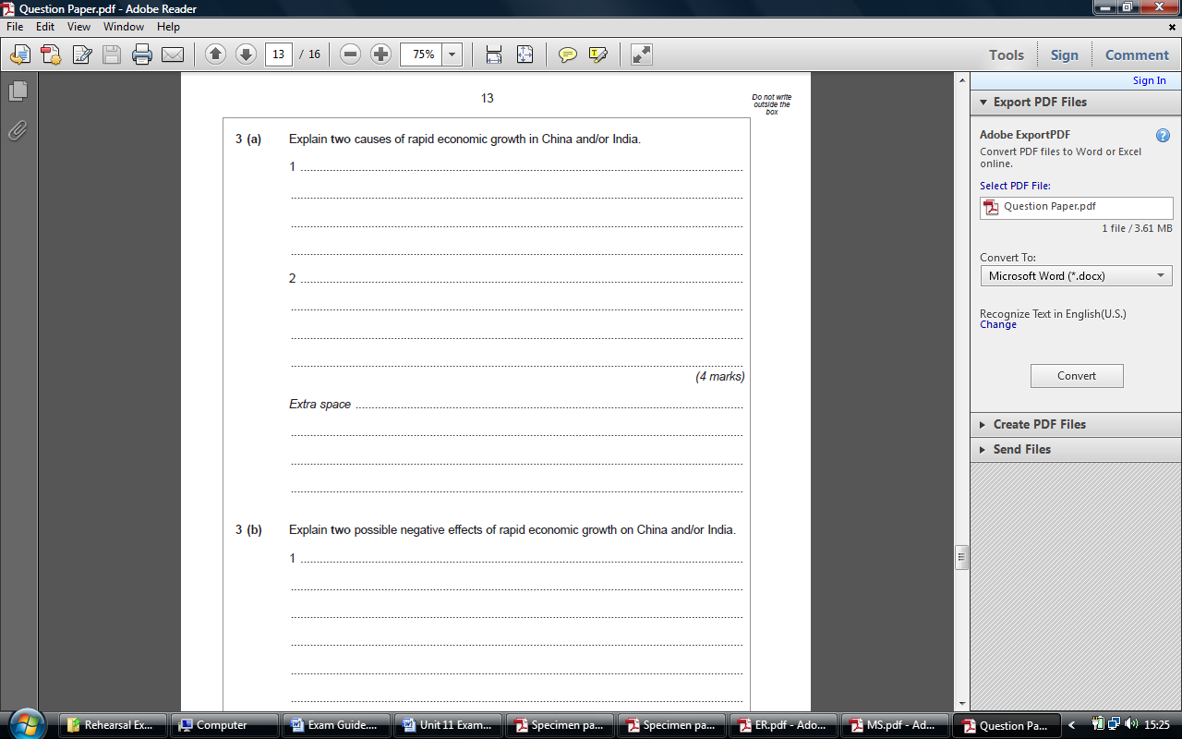

Explain **two** causes of global warming; one for *developed* countries and one for *developing* countries.



**You get one mark for identifying a cause plus one mark for development**

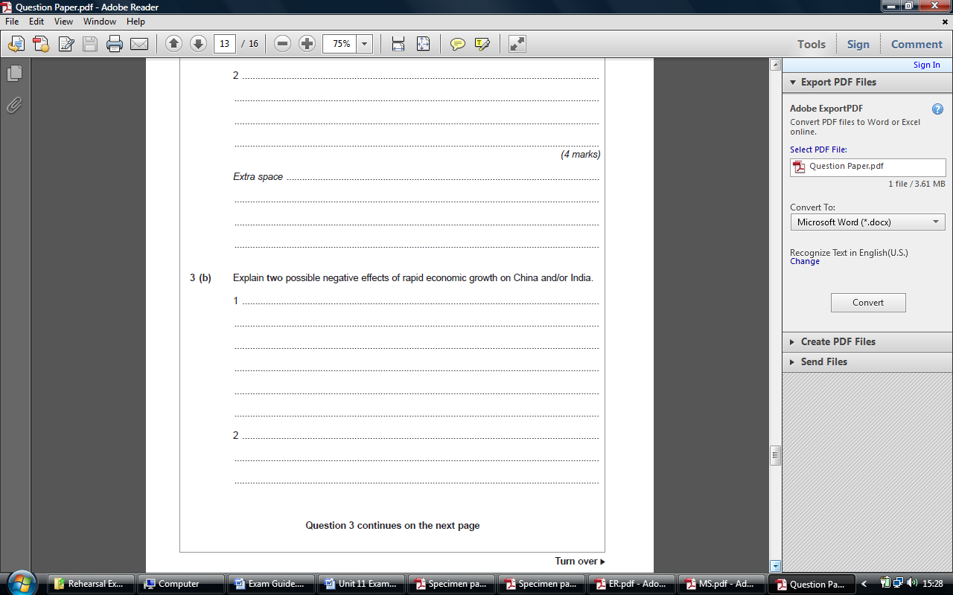

Explain **two** negative economic effects of global warming; one for *developed* countries and one for *developing* countries.



You need to explain each negative effect of global warming in the context of developing an developed countries – linking your ideas to the context is very important!

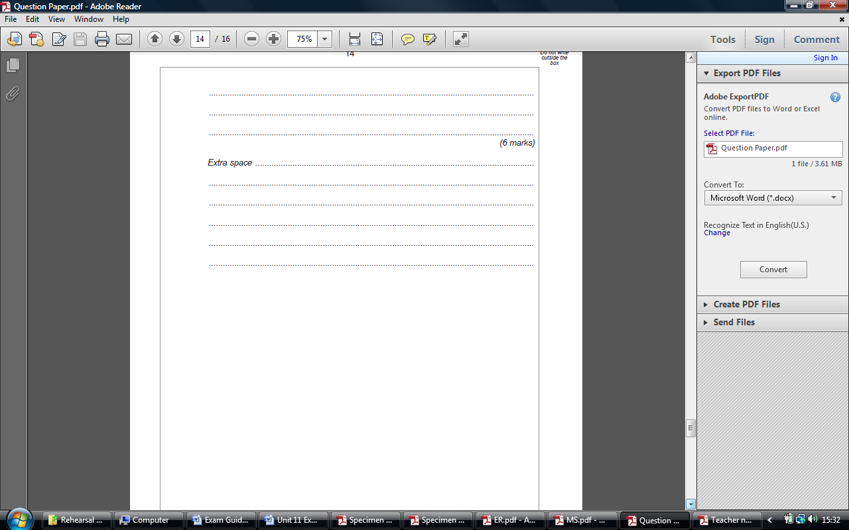

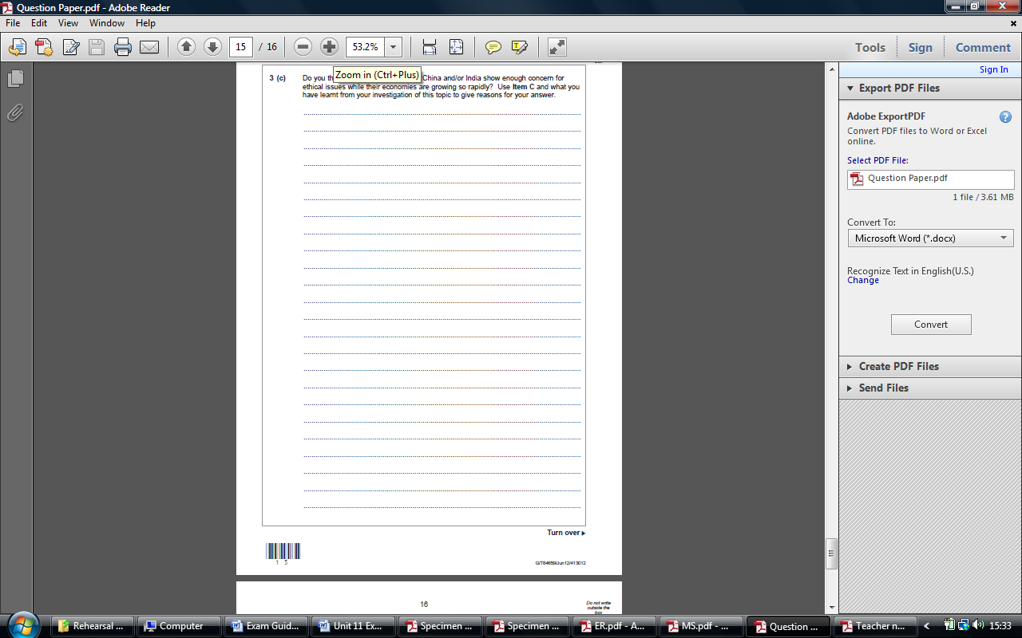

Do you think that developed countries should take responsibility for solving global warming? Use Item C and what you have learnt from your investigation of this topic to give reasons for your answer.

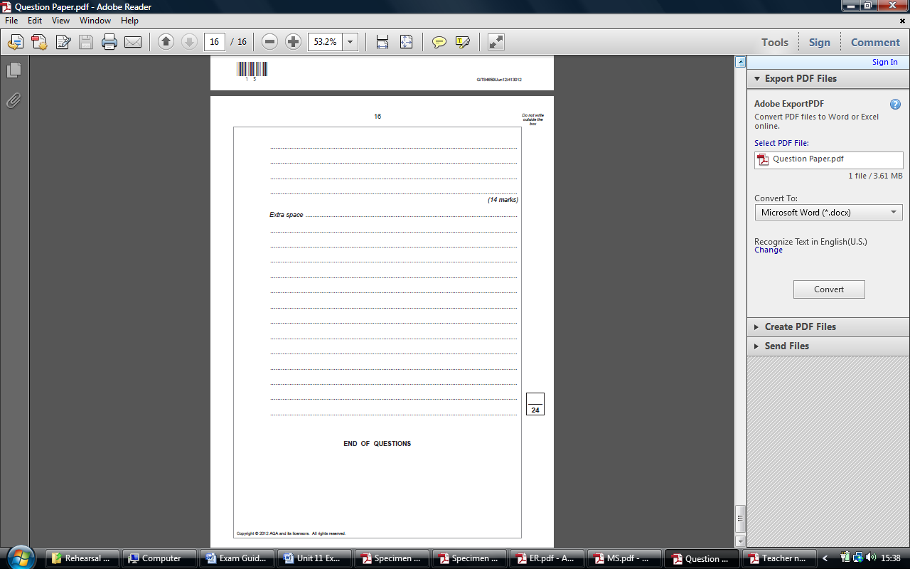

That’s all the questions answered, well done! You now know what to expect in the exam; all that is left for you to do is **REVISE** using your class folders, student workbooks and research projects!



Your knowledge of the *Current Economic Issues* of **Poverty** and **Global Warming** will largely dictate how well you will do in the exam – if you can demonstrate to the examiner your specialist knowledge of these *current issues* you will score a lot more marks!



**8. Useful Websites**

1. **Weebly**: <http://mrtarneconomics.weebly.com>
   1. A great source of additional information and research for the whole GCSE Economics course
   2. It includes a **forum** that you can use to post revision questions and find answers
2. **Tutor2u**: <http://tutor2u.net>
   1. Great search function for current economic issues (e.g. UK Supermarkets) and economic theories and concepts
   2. 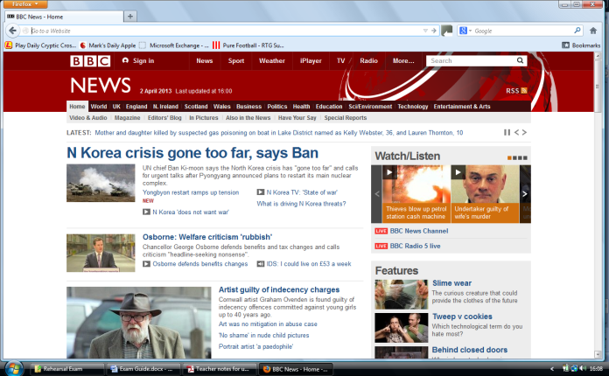The Blogs are a great source for information and condense the latest news in a few short paragraphs

1. **BBC news**:

<http://www.bbc.co.uk/news/>

* 1. Great search function for the topics of Poverty in the UK and Global Warming
  2. You’ll find plenty of useful articles on Managing the Economy such as the latest budget and the latest government policies to control the economy.



1. **The Guardian Newspaper**: <http://www.guardian.co.uk/>
   1. Great search function for current economic issues
   2. AQA has used this newspaper for a lot of its resources so it would be useful for you to have a look at its website
2. **The Telegraph**: <http://www.telegraph.co.uk/>
   1. Great search function for current economic issues
   2. AQA has used this newspaper for a lot of its resources so it would be useful for you to have a look at its website

Remember that the Exam Board (AQA) has provided you will specific resources for both the Current Economic Issues of Poverty and Global Warming – revisit these resources to recap on the issues they cover!

