Ethical solutions to solve UK Poverty

Task1: Look at the possible solutions to UK Poverty below and rank them in terms of whether they are ethical (i.e. what you feel is morally right). For example assign the most ethical solution a number 1 and the least, number 10.

Solutions to UK Poverty | Ranking
Increase the National Minimum Wage (a living wage?)
Improve training and education programmes
Reduce the basic rate of tax from its current level of 20% when you earn over £10,000 a year (starts April 2014)
Increase benefits in kind (i.e. free healthcare, dental treatment, eye care, prescriptions)
Increased provision and availability of food banks
Reduce benefits to encourage those claiming them to find employment and escape the so-called ‘benefits trap’
Improve progression routes for low-paid workers in sectors such as hotels and catering, retail, care and wholesale and transport;
Increase the top rate of tax from its current level of 45% when you earn over £150,000 a year
Increase benefits-in-cash (i.e. JSA, child benefits, heating and housing benefits, disability living allowance, reduction in council tax)
Set a new lower inflation target for the Monetary Policy Committee (currently 2% within a range of 1 to 3%).

Task 2: Which solution to tackle UK Poverty do you think is the most ethical? Explain your answer.

Task 3: Which solution to tackle UK Poverty do you think is the least ethical? Explain your answer.

Ethical Dilemma when trying to solve UK Poverty

Read the case study below and find an ethical solution.

Scenario A: Widowed father
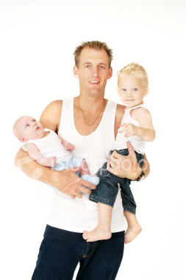
Tony has worked since leaving school, finding employment at the local car garage washing cars and completing minor repairs. He is paid minimum wage.

Unfortunately last year his wife was killed crossing the road, leaving Tony to support his two young children aged 1 and 2. Childcare costs are so high he has been forced to leave his job and claim unemployment benefits. However this has meant that he is on much lower income. He is finding it very difficult to manage his budget often making a choice between feeding and clothing his children and heating his home.

What is your ethical solution to ensure he isn’t living in absolute or relative poverty?

